Title: **MicroLogix 1100 Status Screen** Job: 3

Course: Introduction to Automation Unit: Introduction to PLCs CLO: 1, 4

Name ____________________________ Station _______ Date ______________

**Objectives**

1. Student shall understand the Allen-Bradley MicroLogix 1100 PLC status display.
2. Student shall be able to decipher the status of the PLC inputs using the status display.

**Assessment**

Students shall demonstrate a comprehension of the objectives listed above by scoring a minimum of 75% on this shop job. Grading shall be based on the Introduction to PLC rubric.

**Instructions**

1. On the Main Menu screen of the MicroLogix 1100 PLC, use the up and down keys on the LCD keypad to locate the I/O Status Screen.
2. Press the OK button to select I/O Status.

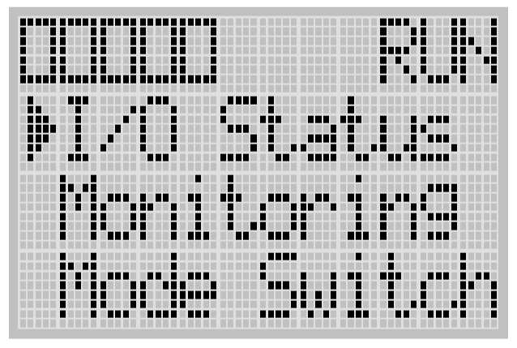

1. The I/O Status screen is displayed. (Input status may differ from picture below)

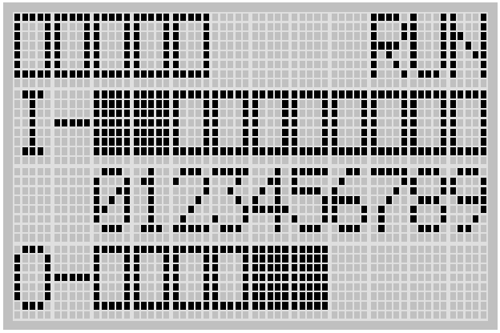

1. Place all the inputs in the following conditions.
   1. ESTOP disengaged (pulled out)
   2. Three-position selector switch in the center, OFF, position
   3. Two-position selector switch in the A position.
   4. None of the pushbuttons depressed.
   5. None of the relays/motor starters “made” (they should be in their shelf state)

|  |  |
| --- | --- |
| The input status screen should look like the following; |  |

This input status screen is indicating that inputs 0, 3 and 4 have 24VDC present. The remaining inputs have 0VDC.

1. With a multimeter set to measure DC voltage, place the black lead on the DC- of the MicroLogix 1100 and test the voltages of each input with the red lead. Record the results in the table below.

|  |  |  |  |  |  |  |  |  |  |
| --- | --- | --- | --- | --- | --- | --- | --- | --- | --- |
| I/0 | I/1 | I/2 | I/3 | I/4 | I/5 | I/6 | I/7 | I/8 | I/9 |
|  |  |  |  |  |  |  |  |  |  |

1. While observing the status screen, press the ESTOP. What happened on the status screen? ___________________________________________________________
2. With a multimeter, measure the voltage between I/1 and 24VDC- of the PLC. Record the voltage. ___________
3. Place the three-position selector switch in the A position. What happened on the status screen? ___________
4. Measure the voltage between I/1 and 24VDC- of the PLC. Record the voltage. ________
5. Measure the voltage between I/4 and 24VDC- of the PLC. Record the voltage. ________
6. While still holding the multimeter leads across I/4 and 24VDC- of the PLC, press and hold down PB1. What happened on the status screen? ___________
7. Record the voltage between I/4 and 24VDC- of the PLC while PB1 is depressed. _______
8. Measure the voltage between I/5 and 24VDC- of the PLC. Record the voltage. ________
9. While still holding the multimeter leads across I/5 and 24VDC- of the PLC, press and hold down PB2. What happened on the status screen? ___________
10. Record the voltage between I/5 and 24VDC- of the PLC while PB2 is depressed. _______
11. Measure the voltage between I/7 and 24VDC- of the PLC. Record the voltage. ________
12. While still holding the multimeter leads across I/7 and 24VDC- of the PLC, press the green manual button on CR1. What happened on the status screen? ___________
13. Note the status of I/8. ________. Manually move the forward motor starter from 0 to 1 using the manual actuator on the auxiliary contacts. (ask instructor for help) What happened? ______________
14. Note the status of I/9. ________. Manually move the reverse motor starter from 0 to 1 using the manual actuator on the auxiliary contacts. What happened? ______________
15. Discuss your findings with your instructor. Instructor Initials _________